
13/10/2019
DECRIPTION ON EXAUST FANS | WRITTEN BY:DEHYA KHURRAIM SIDDQUI & SAFDER REHMAN
FANoFAN | TABLE FANS

Table of Contents

HELIX MEGA ------------------------------------------------------3
STRIKER HI-SPEED ------------------------------------------------------5
MAX AIR SUPER ------------------------------------------------------7
MIST AIR ------------------------------------------------------9
MIST AIR DOUS ------------------------------------------------------11
MIST AIR ICY ------------------------------------------------------13
WIND ------------------------------------------------------15
SWIFT ------------------------------------------------------17
Figures
Figure 1 3
Figure 2 5
Figure 3 7
Figure 4 9
Figure 5 13
Figure 6 15
Figure 7 17
Figure 8 19
HELIX MEGA

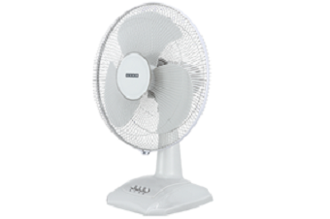
Figure 1
COLOUR: WHITE SPEED: 2200 RPM
SWEEP: 400 mm Power Input: 115 W Air Delivery: 100 M³/Min PRICE: RS 2680

KEY FEATURE:

RPM 2200 100 m³/h 400 MM

STRIKER HI-SPEED

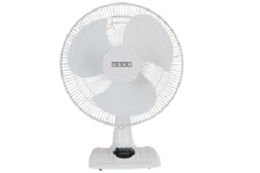
Figure 2
COLOUR: WHITE SPEED: 2100 RPM
SWEEP: 400 mm Power Input: 135 W
Air Delivery: 100 M³/Min PRICE: RS 2680

KEY FEATURE:
RPM 2100 100 m³/h 400MM

MAX AIR SUPER

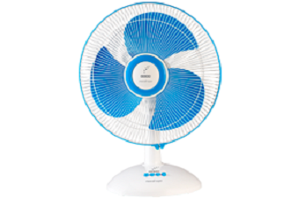
Figure 3
COLOUR: BLUE SPEED: 1280 RPM
SWEEP: 400 mm Power Input: 55 W
Air Delivery: 67 M³/Min PRICE: RS 2250

KEY FEATURE:
RPM 1280 67 m³/h 400MM

MAX AIR

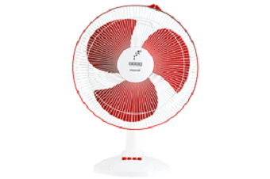
Figure 4
COLOUR: RED SPEED: 1280 RPM
SWEEP: 400 mm Power Input: 55 W
Air Delivery: 67M³/Min PRICE: RS 2250

KEY FEATURE:
RPM 1280 67 m³/h 400MM

MIST AIR DUOS

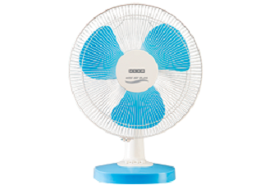
Figure 5
COLOUR: BLUE SPEED: 1280 RPM
SWEEP: 400mm Power Input: 55W
Air Delivery: 60M³/Min PRICE: RS 2190

KEY FEATURE:
RPM 1280 60 m³/h 400MM

MIST AIR ICY

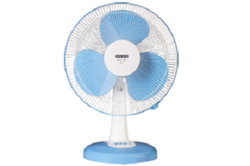
Figure 6
COLOUR: BLUE SPEED: 1280 RPM
SWEEP: 400mm Power Input: 55 W
Air Delivery: 67M³/Min PRICE: RS 2190

KEY FEATURE:
RPM 1280 67 m³/h 400MM

WIND
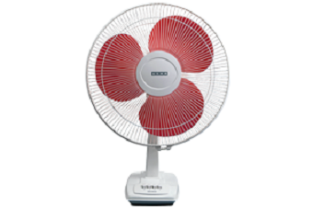

Figure 7
COLOUR: RED SPEED: 1300 RPM
SWEEP: 400 mm Power Input: 52 W
Air Delivery: 70 M³/Min PRICE: RS 2010

KEY FEATURE:
RPM 1300 70 m³/h 400MM

SWIFT

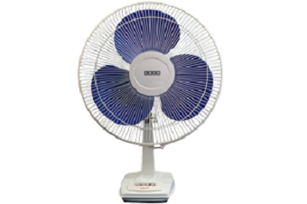
Figure 8
COLOUR: PURPULE SPEED: 1300 RPM
SWEEP: 400 mm Power Input: 52 W
Air Delivery: 70M³/Min PRICE: RS 2010

KEY FEATURE:
RPM 1325 1050 m³/h 300MM

WRITTEN BY

DEHYA KHURRAIM SIDDQUI : WEB DESIGNER
SAFDER REHMAN : WEB EDITOR

IN SUPPERVISION OF

MISS ALMAS.

WEBSITE LINK

